TAX RATE ANALYSIS
Fiscal Year 2018

Report of the

Concord Board of Assessors

Jim Sommer, Chair
Christian Fisher, Vice Chair
Cynthia Rainey
Tom Matthews
Andrea Okie

To

Concord Select Board

For Public Hearing on November 13, 2017

Table of Contents

Page

Purpose..………………………………………….…………………… 3

Recommendation ..……………………………….…………………… 3

Total Assessed Values for Fiscal Year 2017 …….……....…. 3

- Revaluation/Interim Year Adjustment .…………… 3
- Abatements and Adjustments ..…………….……... 4
- New Growth ...…………………………….………. 4
- Change of Taxable Status………………….……… 4
E. Total Taxable Value ……………………………..... 5

- Tax Levy…………………………………………………...… 5

FY2017 Taxable Assessed Value…………………………… 6
Comparative Detail FY16 and FY17………………………... 7

- Tax Rate ……………………………………………………. 8

- Residential Factor …………………………………. 8
- Open Space Discount …………………………….... 9
- Residential Exemption ……………………….……. 9
- Small Commercial Exemption …………………….. 11

Conclusion …………………………………………………………… 11

Addendum 1: State Use Codes……………………………………….. 13
Addendum 2: Assessment/Classification Report FY2017…………… 14
Addendum 3: Comparative Tax Rates……………………………….. 15
Addendum 4: Classification Scenarios………………………………. 17
Addendum 5: Single Family Value Ranges………………………….. 18
Addendum 6: Condominium Value Ranges………………………….. 19

Purpose

The purpose of the public classification hearing is for the Select Board to determine the allocation of the local property tax to be borne by the four classes of real property plus personal property for Fiscal Year 2018. In deciding the allocation, the Select Board must adopt a residential factor, which is used to determine the percentage of the tax levy to apply to each class of real and personal property. The Board of Assessors applies these percentages to the individual property class (M.G.L. Chapter 40, section 56). The Select Board also can vote to adopt a factor for shifting the taxes among residential properties (residential exemption), among commercial properties (small commercial exemption), and between residential and open space properties (open space discount). It is the responsibility of the Assessors to provide the Select Board with all relevant information, and to discuss the fiscal effect of possible alternatives.

Recommendation

The Board of Assessors recommends the Select Board take the following action in adopting the FY2018
factors:
1. Vote a “Residential Factor of “1.”

2. Vote not to grant an Open Space discount.

3. Vote not to adopt a Residential Exemption.

4. Vote not to adopt a Small Commercial Exemption.

These recommendations result in a uniform tax rate of $14.29, up 1.56% from the FY2017 rate. Total taxable value is up 2.87%. Net of new growth, the tax value on all other property will rise 2.38%.

The following is the report of the Board of Assessors to the Select Board.

Total Assessed Values for Fiscal Year 2018

The Board of Assessors must determine the classification of all real property as of January 1, 2017, for
FY2018, in accordance with the definitions set forth in M.G.L. Chapter 59, section 2A(b):

Class One Residential
Class Two Open Space
Class Three Commercial
Class Four Industrial

In addition, the value for all personal property, Class Five, must be determined. The classification, or use, codes are issued in accordance with the Department of Revenue, Bureau of Local Assessment guidelines. A listing of the State Use Classification Codes is attached in Addendum 1 and the total valuation report (LA-4) for FY2018 is attached in Addendum 2.

In FY2018, the town data and values have been affected by the following items:

- Revaluation/Re-certification Adjustment

Per the Department of Revenue’s guidelines, the assessing cycle requires that all parcels, exempt and taxable, be visited at least once every 9 years, that values be determined at market value every year, and that the Department of Revenue recertify values every five years. The last recertification year was FY2015, which means this year Fy 2018 is also a certification year. The year is the last year of the three year cycle. The law was changed as part of the Governor’s municipal reform and has been extended to 5 years.

- Abatements and Adjustments

In FY2017 Concord taxpayers filed 45 applications for abatement during the regular abatement period. The total number of abatements granted was 29. The dollar amount of abatements granted during the FY2017 abatement hearings totaled $4,907,494 for real estate, which is $69,048.47 in tax dollars. The majority of abated taxes was attributed to small corrections in property listings and most resulted in permanent adjustments to the property data. There have been three FY2017 appeals filed with the Appellate Tax Board (ATB).
In order to meet the DOR’s cyclical inspection requirement, assessing staff seeks to conduct a complete inspection of a property regardless of the reason for the visit (building permit, sale, data verification, abatement application, or cyclical inspection, etc.). Every year there are many changes entered into the property records as a result of these inspections. Our records show that there were 716 inspections for FY2018, (just over 11% of all real estate parcels). Of these, 340 were full inspections, inside and out. These numbers do not include when a field review is done from the street, which can include one parcel or many. A field review was performed on all properties as part of the FY 20178 recertification program. A field review usually does not require entering the property and therefore does not meet the DOR’s standard in order to qualify as a cyclical inspection.

New Growth

The Annual Town Meeting in April of 2001 voted to accept a 1989 state statute that changes the new growth date from January 1st to June 30th. Thus, the valuation as a result of new construction or any other physical changes for FY2018 covers the time frame from July 1, 2016 to June 30, 2017.

The new growth represents, new houses, additions or changes to a property that result in added value to that property. The growth this year was higher as compared to the prior year, primarily due to an increase in the volume of building permits, the completion of the new hotel at 320 Baker Avenue and the new condominiums at Black Birch Lane and Black Horse Lane. The growth included 51 new homes, 47 major renovations and 24 major additions. Personal Property new growth is largely due to the addition of property on three accounts Comcast, Kayak, and Welch Foods, Inc.

The growth relevant to FY2018 was distributed among the four classes of real estate and personal property as follows:
Levy Limit % of Total
Value Adjustment New Growth

Class One, Residential $74,008,516 $1,041,299 78.81%
Class Two, Open Space 0 0 0
Class Three, Commercial $ 5,183,219 $ 72,928 5.52%
Class Four, Industrial $ 5,047,424 $ 71,017 5.37%0
Personal Property $ 9,671,970 $ 136,085 10.30 %

TOTAL $ 93,911,129 $ 1,321,330 100.00%

- Change of Taxable Status

From time to time a shift in tax burdens will occur due to a change of taxable status. This year 9x Forest Ridge, 10X Forest Ridge, and 265 Balls Hill Rd. all became exempt this year for a total loss in taxable value of $228,000. This was offset by 26 Brook Trail Road becoming taxable with a value of $580,100.

- Total Taxable value

The total taxable value for FY2018 is $6,144,650,600. A comparison of the Assessment Totals between FY2017 and FY2018 appears on pages 6 and 7. The total town valuation from FY17 to FY18 increases by 2.86%. The change in value by class varies from this total. The increase in the residential class is 2.80%, while the commercial/ industrial and personal property increase is 3.55%. The new growth listed above is included in the totals, so the actual change is $78,023,069 or 1.31%. Note that this represents the change in the market from Calendar 2015 to 2016 and represents a very small change.

Overall, the Residential/Open Space (R/O) portion is 91.52% of the total value and the Commercial/Industrial/Personal Property (C/I/P) portion is 8.48%. These percentages are slightly lower for residential, but consistent with the last several years. The FY2008 portions, ten years earlier, were 91.01% and 8.99%.

II. Tax Levy

At the April 2017 Annual Town Meeting, the taxpayers voted appropriations for the fiscal year July 1, 2017 through June 30, 2018. In addition, certain state assessments, deficits and the overlay must be added to determine the total budget amount. The FY 2018 total General Fund budgeted amount is $101,866,859. Monies to support this local spending are raised by the property tax levy, state aid, local receipts and other sources. The Maximum Permitted Levy is the total amount of money that can be raised through real and personal property taxes and is the largest source of revenue for the town. The Maximum Permitted Levy in FY 2018, including the debt exclusion, is $91,730,540. The actual levy is $87,807,057. The difference between the maximum permitted levy and the actual levy is called excess levy capacity. For FY 2018 the Unused Levy Limit is $3,923,783. The Levy Limit is calculated as follows:

FY2017 Levy Limit $82,116,773
Fy 17 New Growth Adjustment (form LA-13a) $ 0
2 ½% allowed increase $ 2,052,919
New Growth (form LA-13) $ 1,321,330

TOTAL (before debt exclusion and override) $85,491,022

DEBT EXCLUSION $6,239,518
(Principal and interest due on debt authorized
to be repaid from taxation above the levy limit)

OVERRIDE 0

MAXIMUM PERMITTED LEVY $91,730,540

FY2018 PROPERTY TAX LEVY $87,807,057

Unused Levy Limit $ 3,923,783

II. Tax Rate

The tax rate, in its simplest form, is the tax levy divided by the town’s taxable valuation. This is called the Uniform Tax Rate. Under this rate each class of property pays a share of the tax levy equal to its share of the total town value. The calculation for the Town of Concord for FY 2018 is:

$87,809,181 / $6,144,650,600 = .01429

or

$14.29 per thousand dollars of assessed valuation

A tax rate history of both the Town of Concord and surrounding and/or comparable cities and towns is shown in Addendum 3. Of the 12 communities listed, 7 have split rates and 5 have a uniform rate. Despite the residential class advantage in a split rate town, the Town of Concord has repeatedly had the lowest or one of the lowest tax rates for both the Residential and the CIP classes. For FY2018 the town ranked the second lowest in the residential class and the lowest CIP rate in this group.

The Select Board has chosen to adopt a Uniform Tax Rate for the last 20 years. The Select Board must vote the percentages of the tax levy to be paid by each class of real property and by personal property each year (M.G.L. Chapter 40 section 56). In determining the percentages, the Select Board is actually adopting a residential factor.

- Residential Factor

The residential factor adopted by a community governs the percentage of the tax levy that is to be paid by the residential property owners. A residential factor of “1” will result in the taxation of all property at the same rate, the Uniform Tax Rate. The Uniform Tax Rate with a residential factor of “1” is calculated to be $14.29. However, the law allows the Commercial/Industrial/Personal Property, C/I/P, tax rate for the Town of Concord to be as high as 50% above the uniform rate; and the Residential/Open Space, R/O, to be as low as 65% of the uniform rate. A lower residential factor would result in the residential class bearing a lower share of the total levy than its share of taxable assessed value.

History of differential tax rates in Concord

In 1982, the town had a uniform rate and the percentage shares were 18% for the C/I/P, and 82% for the R/O. In 1983, the C/I/P class began to decrease in value relative to the R/O class. The Select Board, at that time, decided to shift the tax burden to the C/I/P class in the interest of maintaining a stable percent balance between the R/O and C/I/P classes. The 1983 vote shifted the levy 9/10ths of a percent to the C/I/P class. The Select Board continued to shift the taxes until 1996, with the maximum shift of 22% occurring in FY 1991.

However, through the mid-1990’s, the total value of the town became increasingly residential. With this residential growth, it was perceived that an increasingly severe shift of the tax levy share to CIP would be required in order to produce only a relatively small benefit to the residential class. Therefore, the Select Board decided to gradually reduce the tax shift, and in FY1997 eliminated this tax shift entirely. In each of the ensuing years, the Board of Assessors has recommended and the Select board has voted to adopt a uniform tax rate for the residential and CIP classes.

Allowable tax shift for FY18

As previously stated, a residential factor of 1 will result in the taxation of all property at the same rate. However, state law permits the town to adopt a residential factor of less than 1, which would have the effect of increasing the commercial, industrial, and personal property tax rates and decreasing the residential tax rate. The chart in Addendum 4 shows the range of allowable residential factor options available to the Select Board.

Recommendation of the Board of Assessors

The Board of Assessors supports a uniform tax rate for all classes, achieved by the adoption of a residential factor of “1.”

- Open Space Discount

Open Space is defined in M.G.L. Chapter 59, section 2A as:

…land which is not otherwise classified and which is not taxable under the provisions of chapters sixty-one, sixty-one A or sixty-one B, or taxable under a permanent conservation restriction, and which land is not held for the production of income but is maintained in an open or natural condition and which contributes significantly to the benefit and enjoyment of the public. [Recently the law was changed to allow inclusion of chapter land.]

State law allows properties classified as Open Space to be taxed at a rate discounted up to 25% from the uniform tax rate. The tax dollars lost by the discount are shifted to the residential class of properties, which includes developable vacant land. The local Board of Assessors must develop the criteria that must be met in order to classify a parcel as Open Space that meets the “significant contribution” for the benefit and enjoyment of the public criteria. Previously Concord has interpreted “significant” as a size consideration, in addition to other factors including view, watershed, trail way, or green belt.

Only one community in Massachusetts grants an open space discount: Bedford. Boards of Assessors use this classification sparingly since most land fits into other classifications, and the open space classification, on its own, makes no difference in the assessment of a property. Assessors have also observed that as the years have passed, many of the land parcels afforded a tax discount were developed anyway, regardless of the tax incentive employed to encourage protection of open land and/or be a deterrent to development.

Presently, there are no parcels classified by the Board of Assessors as Class 2 – Open Space. During the past several years the Assessors have examined the valuation methodologies for land, including undeveloped land, and considered what might be an appropriate policy that Concord could adopt for open space. In particular, vacant land as well as undeveloped lots on a developed parcel were reviewed in detail. Current assessing practices in Concord do not use an aggressive approach to the valuation of undeveloped parcels by assuming maximum developability. Valuing a parcel as excess land results in a more favorable property tax for the owner, rather than assessing it as buildable and then applying an open space discount. The Board of Assessors does not believe there is any advantage to classifying properties as Class 2 – Open Space. Further the tax discount under the Chapter land program is far greater than afforded by the open space discount.

Recommendation of the Board of Assessors

The Board of Assessors recommends that the Select Board not adopt an open space discount since there are no parcels classified as Class 2.

C. Residential Exemption

This mechanism provides for the redistribution of the tax levy among residential property owners, solely within the Residential Class (Class 1). “Exemption” is a misnomer since it is actually a tax shift among residential properties. It involves the following steps:

- Subtracting a standard dollar amount (a percentage of the average Class 1 value) from every qualifying owner-occupied residential parcel;

- Recalculating the Class 1 tax rate based on the new total of the Class 1 taxable value. The Class 1 tax levy must remain unchanged before and after this calculation.

This has the net result of shifting taxes from Class 1 parcels that are below the average value to parcels within the Class that are above the average. It also, however, results in substantially higher taxes on apartment and multi-family parcels that are not owner occupied, on vacant land parcels in the Class, and on any other residential property which is not owner occupied (including, in many instances, properties that are owned by a trust).

The selected percentage to calculate the standard qualifying assessed value reduction can be from 0 to 35%, but selecting a certain percent does not mean that everyone gets that exact percent tax reduction. This is because the tax rate for the Class must be raised. The impact of the exemption – who pays more and who pays less – is not conditioned upon the income status of the occupant. The manner in which the residential exemption works implies the presumption that all occupants of higher-valued properties also have higher incomes.

The average value of Class 1 is $945,311 while the average single family home value is $1,014,302. The exemption, however, would be calculated on the $945,286 value. A 35% shift would be $330,850 exemption in value. The Class 1, residential tax rate associated with 35% exemption would produce a class 1 tax rate of $20.21 up, $5.92 from the rate without the exemption. The break-even point where the rate increase and the exemption amount cross would be on a residential parcel (land and buildings) valued at $1,129,150.

In FY2018 there are 5,949 Class 1 parcels. Based on a “guesstimate” of eligibility, we estimate there are 4,981 potentially eligible properties. To determine the precise number of principal residences would require extensive review of the census, voting, and utility records, car registrations and income tax returns. To implement this exemption, the taxpayers would file an application and include these documents. Their principal residence, indicated by using the above listed documents, would determine their eligibility. Based on the assumed eligible number of parcels, at least 969 residential parcels would qualify for the exemption and experience an increase in their taxes. If the property did not qualify the reduction of $330,850 wouldn’t apply and in addition they would be taxed at the new rate of $20.21. A $400,000 house that did not qualify for the exemption would have an annual tax bill shift or increase of $2,368.

An additional 1,461 (approximate) residential properties (those over the break-even point) would experience an increase. The following are examples of the increase.

Value | No Shift Tax | Shift Value | Shift Tax | Difference
$1,129,150 | $16,135.55 | $798,291 | $16,135.64 | $00.09
$1,551,846 | $16,459.88 | $820,987 | $16,594.39 | $134.51
$2,010,904 | $28,735.82 | $1,680,045 | $33,958.30 | $5,222.48
$2,503,004 | $35,767.93 | $2,172,145 | $43,904.98 | $8,137.06
$3,023,902 | $43,211.55 | $2,693,043 | $54,433.74 | $11,222.19
$4,035,408 | $57,665.98 | $3,704,549 | $74,879.06 | $17,213.07
$5,022,937 | $71,777.77 | $4,692,078 | $94,839.71 | $23,061.94

This option is based on the assumption that a lower value property indicates an occupant with lower income and vice versa. In recent years the Board of Assessors has examined this provision in detail and has continued to recommend against its adoption. The FY2018 data does not indicate any change that would result in a different conclusion.

Only fourteen cities and towns in the Commonwealth use the residential exemption. Two communities joined in FY2006, Everett and Barnstable. Otherwise, this list hasn’t changed in many years. In larger metropolitan communities, the large apartment population essentially funds the exemption (Boston, Brookline, Cambridge, Chelsea, Everett, Malden, Marlborough, Somerville, Waltham, Watertown); in resort communities, the second home population funds the exemption (Barnstable, Nantucket, Tisbury); and in one community, the power plant funds over half of the total levy (Somerset). Thirteen of the fourteen communities also use the CIP tax shift essentially to the fullest degree they can, which means the commercial, industrial, and personal property classes are also called upon to reduce the Class 1 tax bill. (See “A. Residential Factor” above.)

Recommendation of the Board of Assessors

The Board of Assessors does not support adoption of a residential exemption because its impact would be to raise taxes on a substantial number of residential parcels without regard to the fiscal circumstances of the occupants, while lowering taxes on a substantial number of residential parcels whose financial circumstances may not indicate a need for a discounted property tax. (See a report to the Concord Board of Assessors by Lynn Masson and Tony Logalbo on 10/13/05 and The Residential Exemption prepared by Jay E. Closser on 11/25/98) all available at:
http://www.concordma.gov/Pages/ConcordMA_Assessor/FY18INFO

Further, the Board notes the adverse consequences that would result for apartment buildings and multi-family units, which comprise a significant proportion of Concord’s affordable housing stock.

D. Small Commercial Exemption

Under M.G.L. Chapter 59, section 5I, the Select Board may decide annually to exempt up to ten percent of the average value of Class Three(Commercial) The properties have to be occupied by businesses with an average annual employment of no more than ten people. The building value must have a valuation of less than $1,000,000 and the property must be occupied by the eligible businesses as of the January 1 assessment date. The property need not be owned by the eligible business that has been approved as a small business by the DOR. If multiple commercial occupants occupy the building, all occupants must be eligible. The small commercial exemption is a reduction in the taxable valuation of the property applied by the assessors before setting the tax rate. Like the Residential Exemption discussed above, the consequence of the Commercial Exemption is to set a new Commercial Tax Rate higher than the Uniform Tax Rate of $14.29. If adopted, it has the effect of reducing property taxes on certain commercial properties occupied by small businesses and shifting those taxes onto other commercial properties, many of which are likely also occupied by small businesses as either owners or leaseholders.

In FY 2018, the Town of Concord has 335 Class Three commercial properties with a total value of $389,897,200 (excluding mixed use). There are approximately 83 parcels over $1,000,000 and 1 vacant developable parcel. The majority of the remaining parcels are commercial condominiums that may or may not qualify. However, the businesses needs to apply to the DOR to be qualified as a small business. If this exemption were to be considered it would require several years notification, so that the businesses that could qualify would have time to be approved by the DOR. There are a limited number of communities that provide the small commercial exemption including: Auburn, Avon, Bellingham, Braintree, Dartmouth, New Ashford, Seekonk, Somerset, Westford and Wrentham.

The intent of the law is to give a tax reduction to small businesses at the expense of the larger commercial parcels. The question of fairness arises since the legislation is based upon the assumption that the owners of larger buildings are financially healthier than the owners of smaller buildings.

Recommendation of the Board of Assessors

The Board of Assessors does not support adoption of the small commercial exemption (See The Small Commercial Exemption by Jay E. Closser, dated November 25, 1998). Also available at:

http://www.concordma.gov/Pages/ConcordMA_Assessor/FY18INFO

CONCLUSION

In conclusion, the Board of Assessors is unanimous in its recommendation to retain the Uniform Tax Rate of $14.29/$1,000 of valuation for FY18.

The Board of Assessors does not recommend adoption of the Open Space Discount, the Residential Exemption or the Small Business Exemption.

ADDENDA

ADDENDUM #1

State Use Code

Residences
- Single Family
- Condominium
- Mobile Home
- Two-Family
- Three-Family
- Accessory Land with Improvement
109 Multiple Houses on One Parcel

Apartments
111 Four to Eight Units
112 More Than Eight Units

Non-Transient Group Quarters
- Other Congregate Housing

Vacant Land in a Residential Zone or Accessory to Residential Parcel
- Developable Land
- Potentially Developable Land
- Undevelopable Land

Other
- Child Care Facility

Open Space
  - Open Land in Residential Area
210-211 Open Land in Rural Area
220-221 Open Land in Commercial Area

Commercial
  - Transient Group Quarters, Warehouse and Distribution
Facilities, Retail, Office Buildings, Public Service and
Recreational

Industrial
400-452 Manufacturing, Utilities, Mining

Personal Property
501-552

Forest Land (CH 61), Agricultural/Horticultural (CH 61A),
Recreational CH 61B)
- Forest Land
  - Agriculture/Horticulture Land
801-814 Recreational Land

Exempt
900-939 Government-owned, Educational, Charitable, Religious

ADENNDUM # 2
A

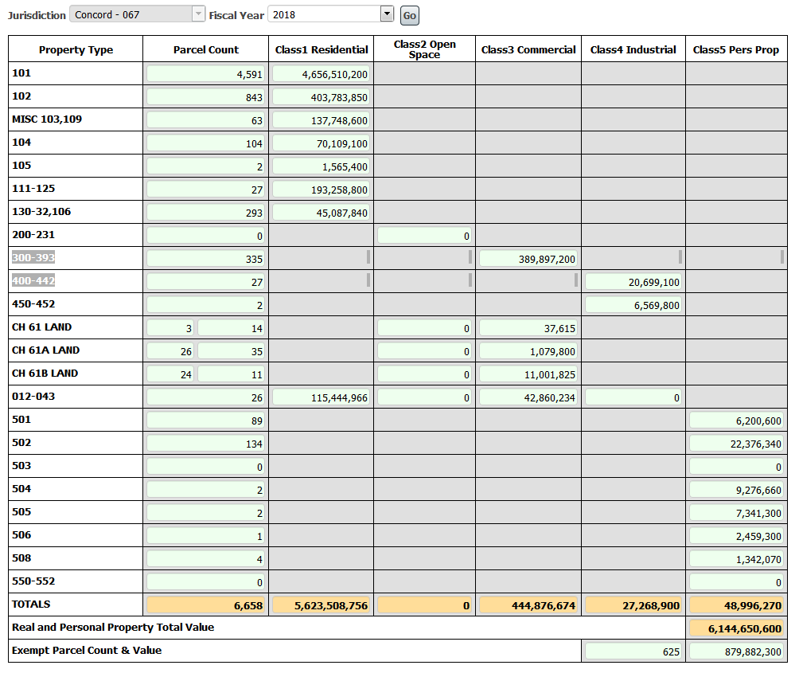

ADDENDUM #5

FY 2018 SINGLE FAMILY RESIDENCE by VALUES – STATE USE CODE 101
(Does not include mixed use 012 or multiple houses 109)
Concord, Ma

Average Assessment: $1,014,269

Median Assessment: $838,900

Addendum # 6

FY 2018 CONDO VALUES – STATE USE CODE 102
(The figures include affordable units, but not separate garages)

Assessment

Average Assessment: $478,984. Median Assessment: $419,200.

